 



Database Programming with SQL 14-3: Managing Constraints Practice Activities

# Objectives

* List four different functions that the ALTER statement can perform on constraints
* Write ALTER TABLE statements to add, drop, disable, and enable constraints
* Name a business function that would require a DBA to drop, enable, and/or disable a constraint or use the CASCADE syntax
* Query the data dictionary for USER_CONSTRAINTS and interpret the information returned

# Vocabulary

Identify the vocabulary word for each definition below.

|  |  |
| --- | --- |
| **DISABLE CONSTRAINT** | To deactivate an integrity constraint |
| **CASCADE clause** | Disables dependent integrity constraints |
| **ALTER TABLE** | To add, modify, or drop columns from a table |
| **ENABLE CONSTRAINT** | To activate an integrity constraint currently disabled |
| **DROP CONSTRAINT** | Removes a constraint from a table |
| **DROP COLUMN** | Allows user to delete a column from a table |
| **CASCADE CONSTRAINTS** | Defines the actions the database server takes when a user attempts to delete or update a key to which existing foreign keys point |

# Try It / Solve It

Using Oracle Application Express, click the SQL Workshop tab in the menu bar. Click the Object Browser and verify that you have a table named copy_d_clients and a table named copy_d_events. If you don’t have these tables in your schema, create them before completing the exercises below.

Here is how the original tables are related. The d_clients table has a primary key client_number. This has a primary-key constraint and it is referenced in the foreign-key constraint on the d_events table.

1. What are four functions that an ALTER statement can perform on constraints?

ADD, DROP, ENABLE, DISABLE

1. Since the tables are copies of the original tables, the integrity rules are not passed onto the new tables; only the column datatype definitions remain. You will need to add a PRIMARY KEY constraint to the copy_d_clients table. Name the primary key copy_d_clients_pk . What is the syntax you used to create the PRIMARY KEY constraint to the copy_d_clients.table?

ALTER TABLE copy_d_clients

ADD CONSTRAINT copy_d_clt_client_number_pk PRIMARY KEY (client_number);

SELECT *

FROM user_constraints

WHERE LOWER(table_name) = 'copy_d_clients' and constraint_type = 'P';

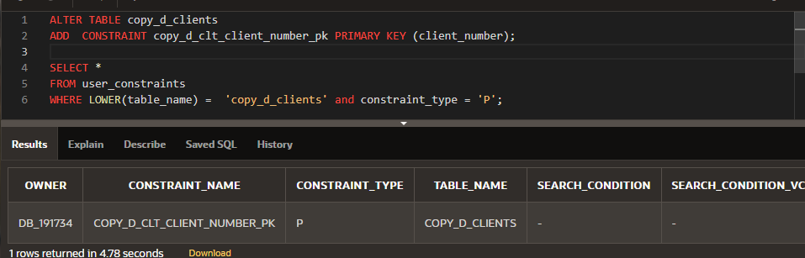

1. Create a FOREIGN KEY constraint in the copy_d_events table. Name the foreign key copy_d_events_fk. This key references the copy_d_clients table client_number column. What is the syntax you used to create the FOREIGN KEY constraint in the copy_d_events table?

ALTER TABLE copy_d_events

ADD CONSTRAINT copy_d_eve_client_number_fk FOREIGN KEY (client_number) REFERENCES copy_d_clients (client_number) ENABLE;

SELECT *

FROM user_constraints

WHERE LOWER(table_name) = 'copy_d_events' and constraint_type = 'R';

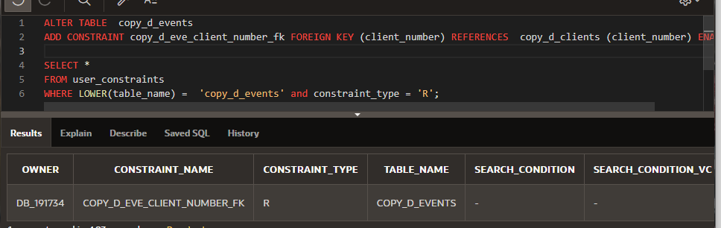

1. Use a SELECT statement to verify the constraint names for each of the tables. Note that the tablenames must be capitalized.

SELECT constraint_name, constraint_type, table_name

FROM user_constraints

WHERE table_name = UPPER('copy_d_events') ;

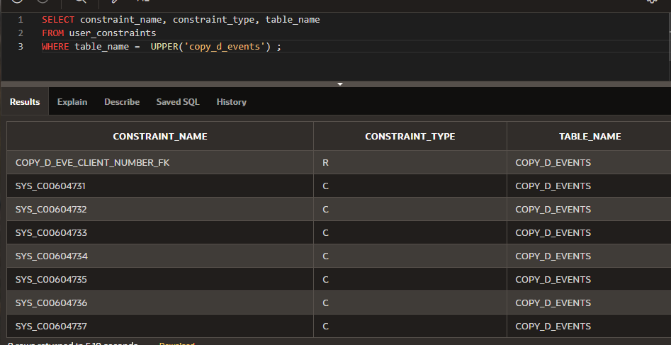

SELECT chld.table_name "Subject", chldcols.column_name "Subject Column Name", chld.constraint_name "constraint_name in Subject", chld.constraint_type "constraint_type in Subject", prnt.table_name "Parent of FK", prntcols.column_name "Parent's Column Name", prnt.constraint_name "Parent PK"

FROM user_constraints chld LEFT OUTER JOIN user_constraints prnt ON chld.r_constraint_name = prnt.constraint_name

LEFT OUTER JOIN user_cons_columns chldcols ON chld.constraint_name = chldcols.constraint_name

LEFT OUTER JOIN user_cons_columns prntcols ON prnt.constraint_name = prntcols.constraint_name

WHERE chld.table_name = UPPER('copy_d_events');

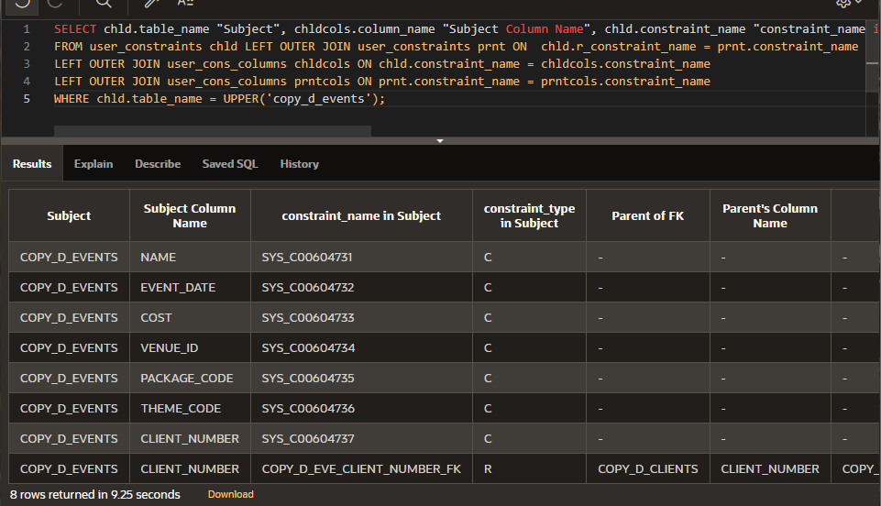

SELECT constraint_name, constraint_type, table_name

FROM user_constraints

WHERE table_name = UPPER('copy_d_clients') ;

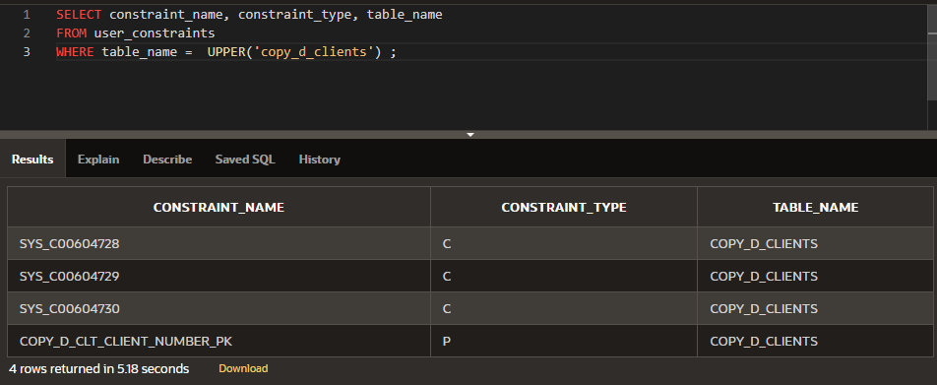

SELECT chld.table_name "Subject", chldcols.column_name "Subject Column Name", chld.constraint_name "constraint_name in Subject", chld.constraint_type "constraint_type in Subject", prnt.table_name "Parent of FK", prntcols.column_name "Parent's Column Name", prnt.constraint_name "Parent PK"

FROM user_constraints chld LEFT OUTER JOIN user_constraints prnt ON chld.r_constraint_name = prnt.constraint_name

LEFT OUTER JOIN user_cons_columns chldcols ON chld.constraint_name = chldcols.constraint_name

LEFT OUTER JOIN user_cons_columns prntcols ON prnt.constraint_name = prntcols.constraint_name

WHERE chld.table_name = UPPER('copy_d_clients');

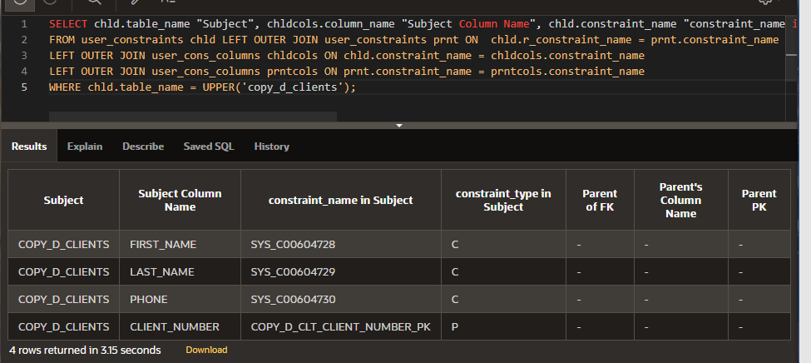

* 1. The constraint name for the primary key in the copy_d_clients table is .

**COPY_D_CLT_CLIENT_NUMBER_PK**

* 1. The constraint name for the foreign key in the copy_d_events table is .

**COPY_D_EVE_CLIENT_NUMBER_FK**

1. Drop the PRIMARY KEY constraint on the copy_d_clients table. Explain your results.

ALTER TABLE copy_d_clients

DROP CONSTRAINT COPY_D_CLT_CLIENT_NUMBER_PK CASCADE ;

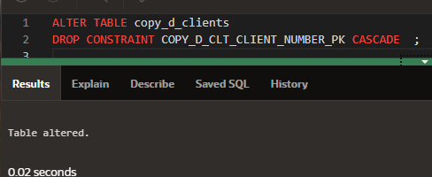

SELECT constraint_name, constraint_type, table_name

FROM user_constraints

WHERE table_name = UPPER('copy_d_events') AND constraint_type = 'R';

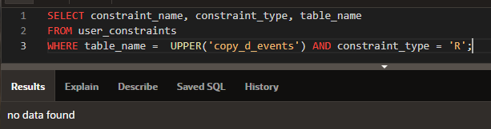

1. Add the following event to the copy_d_events table. Explain your results.

|  |  |  |  |  |  |  |  |  |
| --- | --- | --- | --- | --- | --- | --- | --- | --- |
| ID | NAME | EVENT_DATE | DESCRIPTION | COST | VENUE  _ID | PACKAGE_ CODE | THEME_ CODE | CLIENT_ NUMBER |
| 140 | Cline Bas Mitzvah | 15-Jul-2004 | Church and Private Home formal | 4500 | 105 | 87 | 77 | 7125 |

INSERT INTO copy_d_events(client_number,id,name,event_date,description,cost,venue_id,package_code,theme_code)

VALUES(7125,140,'Cline Bas Mitzvah',TO_DATE('15-Jul-2004','dd-Mon-yyyy'),'Church and Private Home formal',4500,105,87,77);

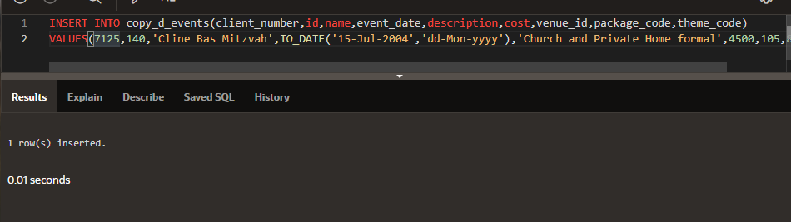

1. Create an ALTER TABLE query to disable the primary key in the copy_d_clients table. Then add the values from #6 to the copy_d_events table. Explain your results.

ALTER TABLE copy_d_clients

DISABLE CONSTRAINT COPY_D_CLT_CLIENT_NUMBER_PK CASCADE;

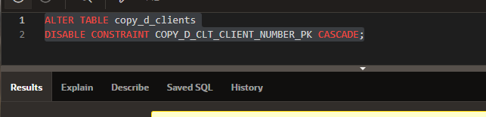

1. Repeat question 6: Insert the new values in the copy_d_events table. Explain your results.

INSERT INTO copy_d_events(client_number,id,name,event_date,description,cost,venue_id,package_code,theme_code)

VALUES(7125,140,'Cline Bas Mitzvah',TO_DATE('15-Jul-2004','dd-Mon-yyyy'),'Church and Private Home formal',4500,105,87,77);

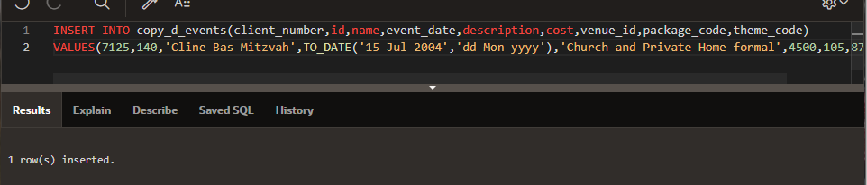

1. Enable the primary-key constraint in the copy_d_clients table. Explain your results.

ALTER TABLE copy_d_clients

ENABLE CONSTRAINT COPY_D_CLT_CLIENT_NUMBER_PK ;

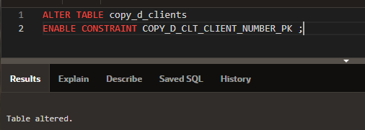

1. If you wanted to enable the foreign-key column and reestablish the referential integrity between these two tables, what must be done?

DELETE FROM copy_d_events WHERE

client_number NOT IN ( SELECT client_number FROM copy_d_clients);

ALTER TABLE copy_d_events

ENABLE CONSTRAINT COPY_D_EVE_CLIENT_NUMBER_FK;

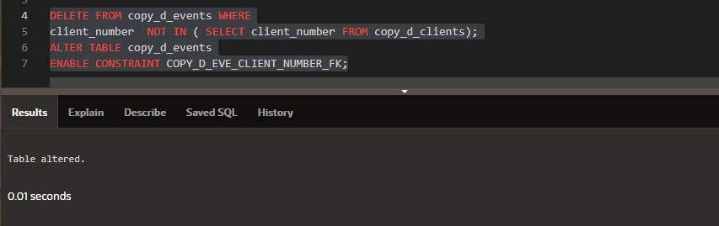

1. Why might you want to disable and then re-enable a constraint?

Для того чтобы ускорить ресурсоемкие массовые операции

1. Query the data dictionary for some of the constraints that you have created. How does the data dictionary identify each constraint type?

SELECT *

FROM user_constraints

WHERE LOWER(table_name) = 'copy_d_clients' and constraint_type = 'P';

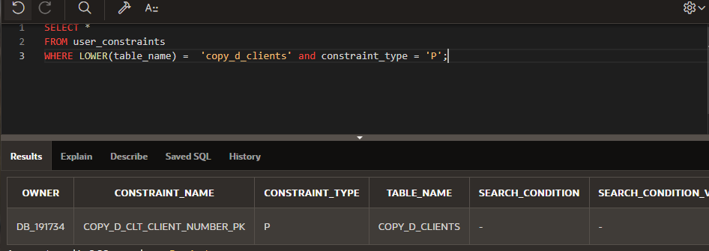

SELECT *

FROM user_constraints

WHERE LOWER(table_name) = 'copy_d_events' and constraint_type = 'R';

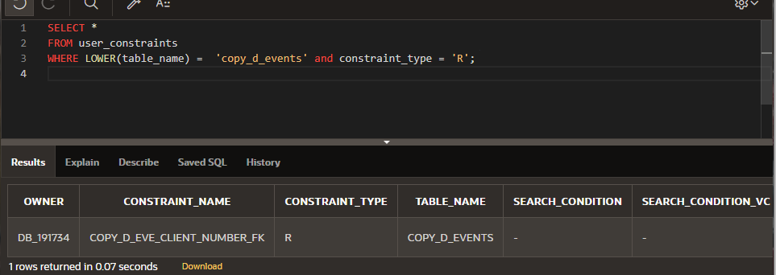

**C**   **C - Check constraint**

**Sub-case - if I see SEARCH_CONDITION something like "FIRST_NAME" IS NOT NULL , its a NOT NULL constraint.**

•         **P - Primary key**

•         **R - Referential integrity (fk)**

•         **U - Unique key**

Copyright © 2020, Oracle and/or its affiliates. All rights reserved. Oracle and Java are registered trademarks of Oracle and/or its affiliates. Other names may be trademarks of their respective owners.